Supporting people with learning disabilities to rent their own places

This easy-read report is a summary of what we heard at 1 national and 8 regional discussion events in England

The events were held on zoom between January and March of 2021.
These events were part of the research project ‘renting your own place’.

The research is funded by the National Institute for Health Research School for Social Care Research.
 | The project team includes an advisory group of people with learning disabilities who rent their own homes and who also belong to self-advocacy groups (York People First; My Life, My Choice).
 | We talked about what it is like to rent your own place and what support people with mild or moderate learning disabilities have or need to rent.
The events were attended by
- people with learning disabilities
- family carers
- advocates
- support workers
- people who work for local councils
- people who work for the NHS
- organisations and people who rent out houses (landlords)
- people who work for voluntary and community organisations
 | We heard lots of different experiences and opinions and have included the main ones here:
 | It can be really hard for people to find somewhere to rent and there is often not much choice
Some landlords think people with learning disabilities won’t be a good tenant.

This can make it harder to find somewhere to live.
Most councils ask people to use ‘choice-based lettings’ to look for somewhere to rent.

People with learning disabilities and their advocates said this is hard to use and not easy to understand.
 | Renting from a private landlord (a house or flat owner who rents out their property to someone else) was not people’s first choice.
 | People told us they were worried about the quality of private rented housing.
 | People were also worried about how long they may be able to live in private rented housing.
 | We heard that most people with mild or moderate learning disabilities do not get much social care support so they often have to rely on their families for help with renting.
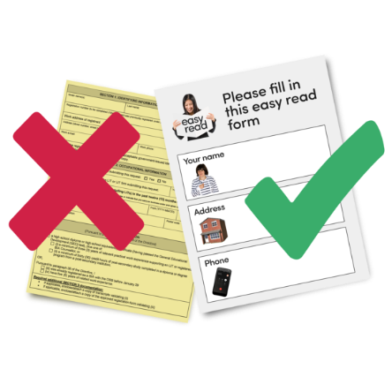 | People with learning disabilities and their families need more accessible information about renting options.
 | Landlords should give easy-read tenancy agreements to everybody.
 | Private landlords need more support and better quality checks are also needed.
 | People want support with their housing that can change depending on what they need.
 | Support that focuses on what people can do works well.
 | Local authorities and advocates need to tell landlords that people with learning disabilities can make excellent tenants.
 | Housing and support providers need to work together better.
 | More funding is needed for flexible support which can save local authorities money in the long term.
 | People with learning disabilities should have more say in how big decisions are made about housing and support.
We are now moving on to the next part of the research.

We are going to interview people with learning disabilities who rent their own place about what it is like to rent and who helps them with this.
We would also like to speak to people who help with renting such as
- family members,
- support workers,
- social workers,
- landlords,
- housing officers,
- anyone else who helps with renting.

We will ask the person renting the place if this is ok with them.
 | If you would like any more information about the research you can contact Eppie who is one of the researchers.
Eppie’s phone number is:

07384239012
Eppie’s email address is:

eppie.leishman@york.ac.uk

This easy-read summary was made using photosymbols.

This easy-read summary is independent research by the National Institute for Health Research School for Social Care Research. The views expressed in this publication are those of the authors and not necessarily those of the NIHR SSCR, the National Institute for Health Research, nor the Department of Health and Social Care

